Rodent Project Name: ___________________
D11 Non-Target Animals

Do Now
Explain how anticoagulants kill rodents.
___________________________________________________________________________________
___________________________________________________________________________________
___________________________________________________________________________________
___________________________________________________________________________________
Vocab: Non-target animal
___________________________________________________________________________________
___________________________________________________________________________________
What are some examples of other animals that might feed upon a rodenticide but are non-targets?
___________________________________________________________________________________
___________________________________________________________________________________

Read the definitions of Primary, Secondary, and Tertiary poisoning below, then label the drawing on the back with each term.

Primary Poisoning of non-target animals may occur when a bird eats the pellets broadcasted on the landscape or pellets that fall out of the bait box. Domestic dogs have been poisoned when they eat bait from boxes or get into unsecured packaging in their homes.

Secondary Poisoning of non-target species occurs when predatory animals eat poisoned animals, therefore ingesting the poisons secondarily. For example, a bobcat eats a poisoned gopher, exposing the bobcat to the poison, creating a secondary exposure to the poison. Your cat could be at risk too. If your cat ventures outside it will likely catch or try to catch a small mammal, if that mouse, rat, squirrel or rabbit has eating poison your cat is at risk of secondary poisoning.

Tertiary Poisoning of non-target species occurs when a predatory animal eats another predatory animal that has been secondarily poisoned. For example, a mountain lion eats a coyote with secondary poisoning that ate a poisoned squirrel.

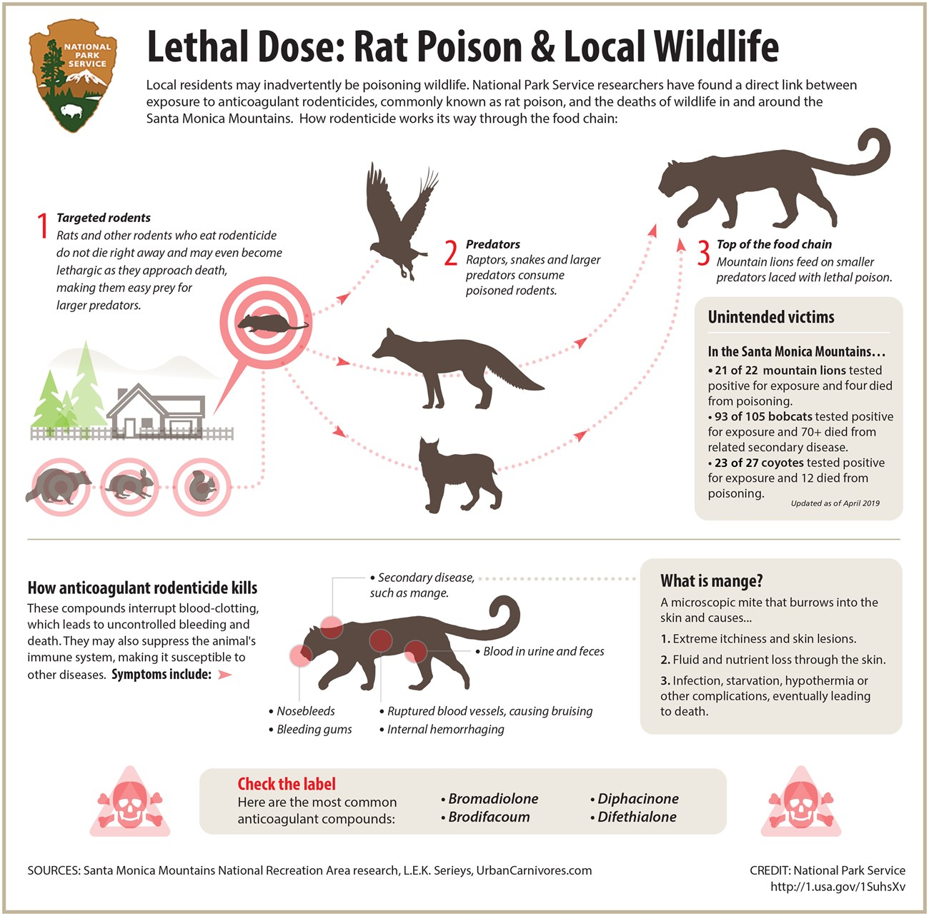
- Read the Dane County Humane Society Rescue Report. What evidence is there that hawks in Wisconsin have been poisoned with rodenticides? Also include if this is primary, secondary, or tertiary poisoning.
___________________________________________________________________________________
___________________________________________________________________________________
___________________________________________________________________________________
___________________________________________________________________________________
___________________________________________________________________________________
___________________________________________________________________________________

